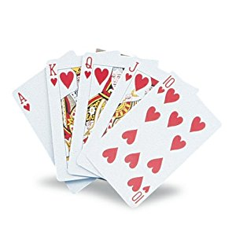PITCH TOURNAMENT
  - HIGH – LOW – JACK – GAME
Date: Friday May 18th 2018
Where: Hollywood Rescue Squad
Time: 7 pm, doors open at 6 pm, MUST BE ON TIME AS ALL TABLES MUST START TOGETHER.
Cost: $20.00, each bump will cost an additional $1.00 per partner at your table, bid 4 and make it, get a chance to win $50.00 from the bump money
Payouts: 1st Place: $150.00 2nd Place: $100.00 3rd Place: $75.00 4th Place: $50.00 5th Place: $25.00
Biggest Loser will receive $20.00 PRIZE MONEY IS GUARANTEED WITH 40 OR MORE PLAYERS
There will be a 50/50 raffle
Need additional information please contact Bonnie Lemonds at:
Email: bonnielemonds@hotmail.com or cell phone 301-247-8397
BYOB
Sodas, water, snacks and food can be purchased.
SPONSERED BY: HOLLYWOOD VOLUNTEER RESCUE SQUAD AUXILIARY

COME OUT AND SUPPORT THE HOLLYWOOD RESCUE SQUAD

